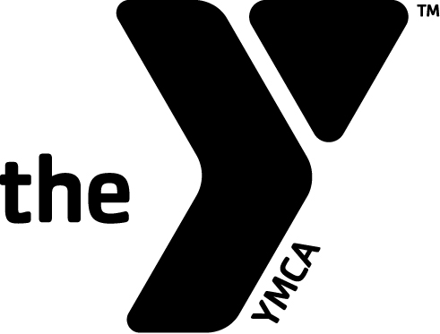
WEST ESSEX YMCA – HERITAGE MIDDLE SCHOOL ATHLETIC PROGRAM

Notification of Medical Issues

MEDICAL RELEASE FORM

Please complete this form and give to your child’s coach on
the first day of sports activities.

Child’s Sport: _______________________________________

Child’s Name: __________________________________________________

Child Information:

List any current allergies:

________________________________________________________________________________________________________________________

Food reactions/ restrictions:

________________________________________________________________________________________________________________________

Medications/Treatment required for allergic reaction:

_____________________________________________________________________________________________________________________

Other pertinent medical information:

________________________________________________________________________________________________________
Parent’s Authorization:

The health history is correct to the best of my knowledge, and the child herein described has vaccination records (or if applicable a written statement of immunization exemption) on file with the Board of Education, is in good health and has permission to engage in all the normal activities of the Athletic Program.

In the event that I cannot be reached in an EMERGENCY, I hereby give permission to the medical personnel selected by the Director to transport my child as needed to the nearest hospital.

____________________________________________ _____________________
Parent/Guardian Signature Date

